CHILD BUDGETING IN ODISHA

An Overview on Off & Departmental Budget Outlay

By
Odisha Alliance on Convention on Rights of the Child

Address:
VII-H-26, Sailashree Vihar, Bhubaneswar-751021, Orissa

Contents
- Introduction

  - Need of Child Budget in Odisha
  - Objective of the Study
  - Methodology of the study
  - Sources of child budget flow
  - Child budget provisions at the departments
- Laws and Policies for Child Protection and Development
2.1. Child Protection Laws and policies in India
2.2. International Convention on child Rights
3. Child Budgeting in Odisha
3.1 School & Mass Education Department
3.1.1 Off Budget for Child Education
3.2 Women & Child Development Department
3.2.1 Off Budget for Child Welfare
3.3. Health & Family Welfare Department
3.3.1 Off Budget for Immunisation & Reproductive Child Health
3.4. ST & SC Development and Minorities & Backward classes Welfare Department
3.5 Sports & Youth Services Department
3.6 Labour & Employment Department
3.7 Works Department
3.8. Tourism & Culture Department
3.9. Child Benefit Budget Overall
Conclusion
Reference

List of Table
I. Child Indicators in Odisha
II. Laws on Protection of Children in India
III. National Policies on Children in India
IV. United Nation’s Convention on Child Rights-1989
V. Departments Addressing Child Issues
VI. Budget for Direct Child Benefit from S & ME Department
VII. Off Budget for Child Education
VIII. Budget for Child Protection, Development & Welfare from W & CD Department (Direct Benefit)
IX. Budget for Child Protection, Development & Welfare from W & CD Department (Indirect Benefit)
X. Budget for Child Health & Nutrition from W & CD Department (Direct Benefit)
XI. Budget for Child Health & Nutrition from W & CD Department (Indirect Benefit)
XII. Budget for Child Education from W & CD Department (Direct Benefit)
XIII. Budget for Child Education from W & CD Department (Indirect Benefit)
XIV. Off Budget Provision for Child Development & Welfare
XV. Budget for Indirect Child Benefit from H & FW Department
XVI. Off Budget for Immunisation and Reproductive Child health
XVII. Budget for Direct Child Benefit from ST & SC Development Department
XVIII. Budget for Indirect Child Benefit from ST & SC Development Department
XIX. Budget for Indirect Child Benefit from Sports & Youth Services Department
XX. Budget for Direct Child Benefit from Labour & Employment Department
XXI. Budget for Direct Child Benefit from Works Department
XXII. Budget for Indirect Child Benefit from Tourism & Culture Department
XXIII. Budget for Child Benefit from Departmental Sources
XXIV. Budget for Child Benefit from Off Budget Sources
XXV. Budget for Child Benefit from Departmental & Off Budget Sources
XXVI. Sectorwise Child Benefit Budget from Off & Departmental Sources
XXVII. Sectorwise Departmental Child Benefit Budget as % of total State Expenditure & GSDP
XXVIII. Departmental Budget for Child Benefit from the state Expenditure and GSDP
Graphs
I. Budget for the children
II. Trend of child budget from S & ME Department
III. Trend of Direct Child Benefit Budget from W & CD Department (Protection, Development & Welfare)
IV. Trend of Indirect Child Benefit Budget from W & CD Department (Protection, Development & Welfare)
V. Trend of Direct Child Benefit Budget from W & CD Department (Health & Nutrition)
VI. Trend of Direct Child Benefit Budget from W & CD Department (Education)
VII. Trend of Indirect Child Benefit Budget from H & FW Department
VIII. Trend of Direct Child Benefit Budget from ST & SC Development Department
IX. Trend of Indirect Child Benefit Budget from ST & SC Development Department
X. Trend of Indirect Child Benefit Budget from Sports & Youth Services Department
XI. Trend of Direct Child Benefit Budget from Labour & Employment Department
XII. Trend of Direct Child Benefit Budget from Works Department
XIII. Trend of Direct Child Benefit Budget from Tourism & Culture Department
XIV. Trend of Departmental Child Benefit Budget for Education from State Expenditure & GSDP
XV. Trend of Departmental Child Benefit Budget for Health & Nutrition from State Expenditure & GSDP
XVI. Trend of Departmental Child Benefit Budget for Protection, Development & welfare Education from State Expenditure & GSDP

Abbreviations
W & CD : Women and Child Development Department
S & ME : School and Mass Education Department
H & FW : Health and Family Welfare
ST : Scheduled Tribe
SC : Scheduled Caste
OBC : Other Backward Classes
NPGEE : National Programme for Girls in Elementary Education
KGBV : Kasturaba Gandhi Balika Vidyalaya
SSA :Sarva Sikhya Abhiyan
DPEP : District Primary Education Programme
EAP : External Aided Project
RSBP : Reconstruction of School Building project
AE : Actual Estimate
RE : Revised Estimate
BE : Budgeted Estimate
CRC : Convention on the Rights of Children
MMR : Maternal Mortality Rate
IMR : Infant Mortality rate
AWC : Anganawadi Center
AWW : Anganawadi Worker
ANM : Auxiliary Nurse Mid-wife
NRHM : National Rural Health Mission
CDPO : Child Development Project Officer
FC : Finance Commission
GSDP : Gross State Domestic Production
SSP : Scheduled Caste Sub Plan
TSP : Scheduled Tribe Sub Plan

Introduction

The United Nations’ Convention on the Rights of the Children (CRC) 1989 has set an international standard on the commitment to the Rights of Children. The range of rights covers the entire spectrum of child life cycle comprising of, right to survival, development, protection, and participation. These components describe about the born rights of each child across the globe. Under right to survival, no child can be discriminated on sex while right to development proclaims about the equal opportunity to all children for their maximum development. On the contrary , right to protection focuses against exploitation of children in any form and right to participation provides opportunity to children to hold up their views in the decision making process. India on her part expressed its solidarity in the international convention to safeguard the rights of children by ratifying the CRC in 1992.According to the CRC, children are the right holders and state is the primary duty bearers. The state shall ensure the implementation of child rights by making suitable legislations, child friendly policies and programmes.
Human development without rights is unthinkable, social development would be hollow without human development. The nation dreams on children would be bigger, if more rights are bestowed on them to realise their full potentialities. To brace the children for the future of a nation has to ensure that the rights are being enjoyed in full extent. The constitution of India has taken care of the well being of the children by recognising the equality of person before law with positive discrimination for the development of all sectors of the community, no matter of their socio-economic conditions at a stretch. Moreover, the Indian constitution is not only a legal document rather it is an inclusive document which is concerned to establish a just, humanitarian and egalitarian society through the democratic functional government. The constitution of India applies uniformly to all, including children. Guided by this scheme of things, the makers of the constitution did not feel to make special provisions for the children as they did for the other groups like women, scheduled castes, scheduled tribes and religious minorities. However, there have been many provisions in the constitution at the subsequent stages to safeguard the interest of the children like free and compulsory education to all children up to the age group of 0-14 years and prohibition of child labour in any form and etc. But the question is in spite of several laws on different child issues, can we proudly claim every child in our state has sufficient food, adequate nutrition, health care and opportunity to go to the school. Do our children have right to born free and lead happy, secured and prosperous life? The answers of these questions would be perplexed because we do have no concerted documentation on the status of children in India as well as in Odisha.
1.1. Need of Child Budget in Odisha
It is well established at the national and international scenario for the infamous child selling incident in Kalahandi district during the eighties. Since then, increasing trend of incidents of child distresses at various parts of the state are coming out in electronics and print media. By looking at the various child development indicators in the state, the following figures are coming in which need sufficient reflection by the policy makers.
Table-I Child Indicators in Odisha
- Children below 18 years of age group constitute 38.8% of total state population
- 0-6 years of children, the number of female children is 952 against 1000 male children.
- Merely 14% birth in the state is properly registered indicating name, nationality and parenthood.
- 77 children before attaining 1 year of age die in every 1000 live births
- 47 new born babies in every 1000 live births die before 28 days of life
- 54.4% babies are born at under weight
- 61.71% children are suffering from different types of mal nutrition
- Out of every 100 enrolled children,32 are dropped out before completing primary education
- The rate of drop out is 52% among the tribal children at the primary level
- 23% girls before attending 18 years of age group are married
- 20 children of 0-14 years are suffered from either type of disability out every 1000 children

The government both at the state and centre have not only enacted laws against child crimes but also have introduced several welfare measures for their development. It is keenly observed in tribal areas that the state of primary and secondary education is very much precarious. Very small number of primary class children are coming to school for the sake of mid day meals. Most of the primary schools are found non functional due to absent of teachers. The plight of pre-school education is also defunct due to non availability of AWC buildings. Students interested for secondary education do not find schools at their localities. The most significant fact is that whatever incentives for education are provided by the government to the children are not reaching them properly. With these situations, the parents’ are not sending their children to schools rather prefer to engage them in different types of hazardous activities to earn income for the family. Exploitation of children are found every sector in the economy. In spite of law, child trafficking and abuse has gone up sky height in recent years.

Looking at the child health aspects of the state, the situation is not as good as the education. Due to lack of sufficient child and mother care initiatives, the child mortality rate in Odisha is highest in the country as per sample registration bulletin, government of India. The MMR is also much high as compared to the national level. Malnutrition is found to be a serious threat for the state leading to significant number of grade III and IV children. All these incidents happen due to budgetary constraints and lack of proper monitoring system.
When the government is looking for more to more skilled and healthy human resources in the state, by that time the net enrolment and dropout rates in the schools are reducing or remain constant. Large numbers of children are uncared in the society due to poverty, superstition, ill practices, lack of facilities and harassment. At this stage, it is the government can play the vital role for improving the situation through proper budgeting practices and monitoring mechanisms.
1.2. Objective of the Study
It is normally observed that the child status in Odisha is not much healthy as compared to other developed states of our country. The reason of this unhealthy status is lack of proper implementation of government programmes for the wellbeing of children in the state. Lack of co-ordination, monitoring, infrastructure facilities and human resources are the major contributors towards distress of children in a big way. Generally, it is treated that the financial factor is the principal cause for the evolvement of all these negative forces against the proper implementation of government programmes towards child welfare. Therefore, this study desires to explore the child welfare of the state based on the following objective
- To track the departmental budget provision for child welfare
- To track the budgetary allocation for child welfare from the state expenditure and GSDP
1.3. Methodology of the Study
This study on child budget in Odisha is purely based on the secondary government budget data from different sources like demand for grants, budget at a glance and annual reports from 2007-08 to 2011-12 financial years. Apart from, different secondary data sources (government & non government) also have been explored to gain data for the report to cover up other developmental indexes of children in the state. While calculating budget data for various departments from the demand for grants, specific software was also used to make it errorless.
1.4. Sources of Child Budget Flow
Before describing about the detail budgetary provisions, one should have knowledge over the frame work of child budget flow mechanism in the state.
Gra-I
BUDGET FOR THE CHILDREN
OFF BUDGET
OFF DEPARTMENT
(OTHER THAN NODAL DEPARTMENT)
NODAL DEPARTMENT
(W & CD)
Assistance & Schemes,Govt. of India
EAPs

Fig-I, shows that budget for children normally comes from three different sources like from the nodal department, off departments and off budget. Here the department of W & CD as the nodal department plays the major role for the development of children in the state. Besides, the department of W & CD, other departments (described below) are also having budgetary provisions for the development of children. These departments are known as off departments for provisioning of child budget and spending. The last category of source for child budget is off budget. Off budget normally means to the budget which is not routed through the legislative processes. Again, it comes from two sources like from central government assistance and external aids. Usually off budget comes in form of schemes and programmes where the state government has to bear a certain proportion of the total budget required for the implementation of such schemes or programmes. The examples in this case are SSA, NRHM and etc.
1.5. Child Budget Provisions at the Departments
It is described earlier that as per the desire of the constitution, separate provisions have been created for the scheduled castes, tribes and minorities in the field of education, employment, governance and etc. Likewise, as per the FRBM Act, there have been strict guidelines for the governments at different levels to have separate budgetary provision in each of the department for the scheduled castes and tribes. Matching with their percentage of the total population, proportionate budget remains reserved for the welfare of scheduled castes and tribes in each department. But, this practice is not found in case of children at neither of the governments. It is seen that a very few departments in our state have the provisions of exclusive child budget components. On the other hand, there have been some budgetary components in these departments which bear the benefits both for the children and youths as well. The departments which bear the exclusive components of child budget provisions are
- Women and Child development Department
- School & Mass Education Department
- Health & Family Welfare Department
- Labour and Employment Department
- STs & SCs Development and Minorities & Backward Classes Welfare Department
- Sports and Youth Services Department
- Works Department
- Tourism and Culture Department
From the above eight departments, the first two departments are primarily concerned with the issues and welfare of the children in the state. On the contrary, the rest six departments are also having child welfare budget components but not their focused area of intervention.
Apart from the above departments, there are some other sources which are also concerned with the issues of education and health of the children in the state. These sources are known as off budget sources because budget spent for various activities and programmes under these sources are not routed through the legislative process of the state. In this context, the measure off budget supported programme and activities in education, health and child welfare are
- Sarva Sikhya Abhiyan
- Kasturaba Gandhi Balika Vidyalaya
- National Programme for Girls in Elementary Education
- District Primary Education Programme
- Reconstruction of School Building project
- Quality enhancement Unit
- Routine Immunisation Programme
- Immunisation
- Pulse Polio
- Reproductive Child Health(Ph-II)
- Dhanalaxmi conditional cash transfer scheme for girls with insurance coverage

Laws and Policies for Child Protection and Development
It has been observed across the globe that the basic human rights of children are grossly violated. They are not given chance to expose of their potentiality in the natural process of development. Due to ignorance and lack of protest power, they have been exploited in almost all the sectors. Parents in the under developed and developing nations are engaging their children in different economic and social sectors for earning more. Out of illiteracy and ignorance, these parents are not in position to think of the economic prosperity through proper care of their children. There are number of examples that the life of a child has been spoiled once for all through immoral engagement in different activities. The parents of these children do not realise the fact out of temporary benefit for a quite few period. The plight of children in the country like India is precarious. It is observed that out of poverty, parents even if do not hesitate to sell their children at few rupees. Children especially from SC and ST community are working in different hazardous sector where they have been exploited in different forms like psycho-physical abuse, no payment, no fooding, no proper environment of staying, and no minimum care during illness and so on. This situation, in context of Odisha is very much acute. Looking in to the aforesaid plights of children, there have been many laws enacted at the national and international level to protect the basic rights of children across the globe. Therefore, the laws and policies which are found at the national and international level to safeguard the interest of the children are as follows.
2.1. Child Protection Laws and Policies in India
The term developed nation refers to a situation where existing resources are properly explored and utilised for the maximum benefit of the citizens. Here, existing resources does not mean to mineral and other forms of natural resources only, rather it includes human resource as well. It has been well found in many civilisations that proper utilisation and care of human resource has resulted tremendous impact to make the civilisation advance as compared to others. Based on the human value, the western countries now in the world are being treated as most developed countries. These countries have recognised the role of their children properly as the builders of the future nation. But, India being the largest democracy in the world, seems to be much backward in recognise the role of children in building of the nation. In spite of several laws and welfare programmes for the protection and development of the children in the country, the incidence of child harassment, exploitation and abuse has not reduced significantly as expected by the policy makers. The vital reasons of this insignificant result of child development programmes and laws are lack of political will and proper execution and monitoring mechanism. Every day issues like child trafficking, child abuse and child needs care and protections are coming up in large numbers in different Medias. But, due to lack of quick response mechanism, these children can not avail justice in time. However, the government of India has made several laws and policies for child protection and development which are depicted at the following.
Table-II Laws on Protection of Children in India
Sl.No | Name of the Act | Objectives
1 | Guardians & Wards Act,1890 | This act deals with the qualification, appointment and removal of guardians of children by courts and is applicable to all children irrespective of their religion.
2 | Child Marriage Restraint Act, 1929 (Amended in 1979) | This act lays down minimum age of marriage on both the sexes. This act prohibits child marriage but it does not invalidate once marriage is solemnised. This law is applicable to all communities irrespective of their religion.
3 | Hindu Adoption and Maintenance Act , 1956 | This act codifies the law of adoption and maintenance. This other provides for adoption of boys and girls. This act applies fully to Hindus, Buddhist, Jains or Sikhs by religion and not to Muslim, Christian, Parsi and Jews.
4 | Immoral Traffic (Prevention) Act,1956(Amended in 1956) | This act prohibits trafficking in human beings and prescribed stringent action against those inducing children (below 16 years) and minors (16-18 years) in the offences of procuring, inducing or taking a person for the sake of prostitution.
5 | Orphanages & Other Charitable Homes(Supervisions and Control)Act 1960 | This act provides for the supervision and control of Orphanages and Homes for children.
6 | Bonded Labour System (Abolition) Act 1976 | This act purports to abolish an agreement and obligations in order to free bonded labourers.
7 | Child Labour (Prohibition & Regulation) Act,1986 | This act prohibits the engagement of children in certain employment and regulates the conditions of work of children in certain other employment.
8 | Infant Milk Substitute, Feeding Bottle and Infant Foods (Regulation of Production, Supply & Distribution) Act 1992 (Amended 2003) | The act aims to project and promote breastfeeding, ensure the proper use of infant’s foods by regulating the production, supply and distribution infant milk substitutes, feeding bottles and infant foods.
9 | Pre-Conception and Pre-Natal Diagnostic techniques (Prohibition of Sex Selection) Act 2003 | This act provides regulation of the use of pre-conception and pre-natal diagnostic techniques for the purpose of detecting genetic or sex linked disorders and for the prevention of the misuse of such techniques for the purpose of pre-natal sex determination leading to female foeticide.
10 | Person with Disabilities(Equal Protection of Rights and Full Participation) Act,1995 | This act has ensured the responsibilities of the central and state governments with regard to services for disabled persons. The act also speaks about education of children disabilities up to age of 18 years in an appropriate environment.
11 | Juvenile Justice ( care and Protection of Children) Amendment Act,2006 | This act deals with the laws relating to Juvenile in conflict with law and children in need of care and protection. It contains provision for proper care, protection and treatment by catering to their development needs and by adopting child friendly approach in the adjudication and disposition of matters in the best interest of the children and for their ultimate rehabilitation and for matters connected therewith or incidental thereto.

Table-III National Policies on Children in India
Year | Policy | Objectives
1974 | National Policy for Children | The policy declares that children are the supremely important assets of the nation and states that children’s programme should find a prominent place in our national plans for the development of human resources.
1986 | National Policies for Education(NPE)  NPE Modified 1992  Sarva Sikhya Abhiyan | All children having attended 11 years age by 1990 will complete 5 years of schooling. By 1995 all children up to 14 years will be provided free and compulsory education.  Universal Primary Education by 1995  All Children in School or Education Guarantee Center /Alternative School by 2003.  5 years Primary Schooling for all children by 2007  8 years schooling for all children by 2010  Bridging all gender and social category gaps at primary level by 2007 and upper primary level by 2010  Focus on Quality Education  Emphasis on Infrastructure Improvement in Schools  (SSA Programme has been operating in Odisha since 2003)
1987 | National Policy on Child labour | Setting up of the National Child Labour Project (NCLPs) for the identification, withdrawal and rehabilitation of child labour.  (18 nos of child labour projects with 653 special schools arte in operation in 18 districts of Odisha)
1993 | National Nutrition Policy | Aims act eradicating malnutrition and achieving optimal nutrition for all.
2002 | National Health Policy | Providing Universal Health Care and access to medical services covering preventive, promotive and curative aspects to all sections of the society.
2003 | National Charter of Children | Intent to secure for every child its inherent right to be a child and enjoy a healthy and happy childhood, to address the root causes that negate the healthy growth and development of children and to awaken the conscience of the community in the wider societal context to protect the children from all forms of abuse, while strengthening the family and the nation.
2005 | National Commission for Protection of Child Rights Bill | Intent to uphold the child rights and to take suo motto cognisance of child rights violation.

2.2. International Convention on Child Rights
It has been mentioned earlier that the issues of children has now become a global concern instead of national disquiet of any nation. Mostly, child issues like trafficking, exploitation, sexual abuse, harassment and deprivation from minimum human rights are found in developing and under developed countries. Though, some countries from the developing and under developed world have come forward with certain laws and policies for the development of children, but those provisions are not sufficient based on the situational requirement. In this context, there is urgent need of fresh international laws on child issues which will be binding to each of the member state of united nation. However, an inter national convention on child rights was summoned by the united nation in the year 1989 which had adopted different steps against various issues of children in the member states. That convention also urged to the member states to adopt exclusive laws and policies for the children based on the declarations of the summit. Some of the declarations of united nation’s convention on child rights 1989 are as follows
Table-IV United Nation’s Convention on Child Rights 1989
Article | Declarations
Article-2 | The state will ensure against all forms of child discriminations based on status, activities, opinion or beliefs of the child’s parents, legal guardians or family members.
Article-3 | Best Interests of the child must be a primary consideration for the authorities of a state while taking decision, which affects the child.
Article-4 | The state shall undertake all appropriate legislative, administrative and other measures for the implementation of the child rights recognised in the present convention.
Article-5 | Respect for family’s responsibilities, rights and duties of parents towards child.
Article-6 | Inherent right to life, right to survival and development.
Article-7 | Rights of the child to be registered after birth, right to acquire a name and nationality, right to know and be cared for by his or her parents.
Article-8 | Right of the child to preserve his/her identity including nationality, name and family relations.
Article-9 | Rights of child to continue in family unit.
Article-10 | The rights of the child for correctives for the situation on separation from family.
Article-11 | Prevention by state parties of illicit traffic in children.
Article-12 | Personal freedoms of the child.
Article-14 | Rights of the child to freedom of thought, conscience and religion.
Article-15 | Rights of child to freedom of association and to freedom of peaceful assembly
Article-16 | No arbitrary or unlawful interference with privacy, family, home or correspondence of children along with no attacks on their honour and reputation.
Article-18 | Enforcement of responsibility of parents.
Article-20 | Prevention of deprivation of family environment and proper regulation of adoption.
Article-24 | Right of the child to the enjoyment of the highest attainable standard of health.
Article-26 | Guarantee of social security and a good standard of life.
Article-28 | Imparting of compulsory Primary Education.
Article-31 | Social and cultural rights of the child.
Article-32 | Prevention of economic exploitation of the child.
Article-33 | Protection of children from illicit use of narcotic drugs and psychotropic substances.
Article-34 | Prevention of sexual exploitation and sexual abuse of the child.
Article-35 | Prevention of abduction, sale or traffic in children.
Article-37 | Prevention of torture or other cruel, inhuman or degrading treatment or punishment to the child.

Child Budgeting in Odisha
It has been mentioned in the introduction that there is no formal provision of child budget practice in each department of the state government like the special provision for scheduled caste and tribe population to protect the interest of children. But, whichever departments are having child budget components in the state budgetary process are not mandatory. Looking in to the nature of interventions by those child budget components, the entire 8 departments are coming under three broad categories like child education, health & nutrition, protection, development & welfare. A table at the following can clear the concept.
Table: V Departments Addressing Child Issues
Issues | Departments
Education | - School and Mass Education  - Women and Child Development Department  - STs & SCs Development & Minorities & Backward classes Welfare Department Works Department  - Works Department
Health & Nutrition | - Health and Family Welfare Department  - Women and Child Development Department
Protection, Development & Welfare | - Women and Child Development Department  - Labour and Employment Department  - Sports and Youth Services Department  - Tourism and Culture Department

3.1. Department of School & Mass Education

The department of school and mass education is a major department which deals with the interest of the children. As we know that education is the backbone of human civilisation. Without education, human potentiality can never be properly exposed. Hence, every citizen of a nation is more or less influenced by the intervention of the department of education. In this context, we are concerned with the budgetary provision of the department of school and mass education, government of Odisha. It has been worked out at the following to trace out the child budget components from the department of school and mass education and how far this department has been able to meet the aspirations of children through its budgetary provisions. The graph-II and the table-VI at the following explain the fact more elaborately.

Table: VI Budget for Direct Child Benefit from S & ME Department(Rs in Crs)
Budget Component | 2007-08AE | 2008-09AE | 2009-10AE | 2010-11RE | 2011-12BE
Educational Facility for Handicapped | 0.99 | 1.22 | 1.40 | 1.83 | 1.71
Integrated Education for the Disabled children (IEDC) | 0 | 5.25 | 4.21 | 8.27 | 0
Supply of Uniform to Girl students | 0 | 0 | 3.50 | 4.00 | 0
Pre-matric scholarship at primary level | 0 | 0 | 0 | 3.22 | 0.64
Pre-matric scholarship at secondary level | 0 | 0 | 0 | 0 | 0
Distribution of free bicycle to all girl students of class-X of govt and govt aided high schools | 0 | 0 | 0 | 0 | 45.00
Text Book | 12.73 | 11.22 | 13.34 | 17.44 | 18.69
Total Child Component | 13.72 | 17.69 | 22.45 | 34.76 | 66.04
As % of Department Budget | 0.58 | 0.53 | 0.55 | 0.62 | 1.24
Total Budget for S & ME | 2379.56 | 3351.17 | 4107.66 | 5590.09 | 5315.44
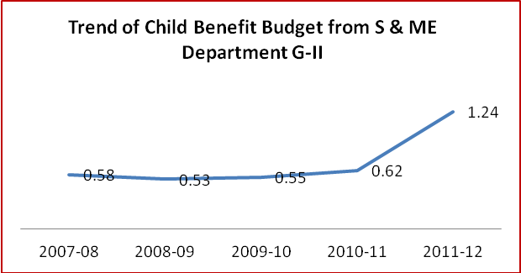
As per graph-II, the percentage of child budget from the school and mass education budget is marginally increasing since 2008-09 to 2010-11 i.e 0.53%-2008-09,0.55%-2009-10 and 0.62% in 2010-11.But,during the 2011-12,this percentage has sharply raised to 1.24% which indicates a healthy sign towards more number of child benefits.
For details table-VI can be referred.
Source:-Demand for Grants, Government of Orissa
By looking at the table-VI, there are seven budget components are found to be child focused in the department of school and mass education. Those components are education facility for handicapped, integrated education for disabled children, supply of uniform for girl students, pre-matric scholarship at primary and secondary level, distribution of free bicycles to girl children at class-X and text book support. It is observed from the table that no budgetary provision has been made for the students at the secondary level. Likewise very insignificant budget has been allocated for students at the primary level for the year of 2011-12(64lakhs).Besides; there is no budgetary allocation for the year 2011-12 under the child budget components of integrated education for disabled students and supply of uniform to girl children. Another point of focus is that except the year 2011-12, there was no budget provision for distribution of free bicycles to the girl students at class X. From the above budget components, it seems that the government is lack of constant policy of child budget from the department of school and mass education.
3.1.1. Off Budget for Child Education
It has been mentioned earlier that the child education in Odisha is not only run by the budgetary support of the state government but there are some other sources which also contribute a significant amount of budgetary support to the education programme in the state in form special programmes and activities like Sarva Sikhya Abhiyan(SSA),National Programme for Girls in Elementary Education(NPGEE),Kasturaba Gandhi Balika Vidyalaya, District Primary Education Programme(DPEP),Reconstruction of School Building Project(RSBP) and Quality Enhancement Unit.
Table: VII Off Budget for Child Education (Rs in Crs)
 | 2007-08 AE | 2008-09 AE | 2009-10AE | 2010-11AE | 2011-12BE
National Programme for Girls in Elementary Education(NPGEE) | 30.01 | 22.10 | 25.07 | 23.97 | NA
As % of total Exp | 3.58 | 2.50 | 14.59 | 2.81
Sarva Sikhya Abhiyan(SSA) | 739.57 | 796.68 | 105.37 | 801.18 | NA
As % of total Exp | 88.11 | 90.22 | 61.34 | 93.97
Kasturaba Gandhi Balika Vidyalaya(KGVB) | 21.94 | 26.47 | 41.34 | 27.32 | NA
As % of total Exp | 2.61 | 3.00 | 24.07 | 3.20
District Primary Education Programme(DPEP) | 47.82 | 37.76 | 0 | 0 | NA
As % of total Exp | 5.70 | 4.28 | 0 | 0
Reconstruction of School Building Project(RSBP) | 0 | 0 | 0 | 0 | NA
As % of total Exp | 0 | 0 | 0 | 0
Quality Enhancement Unit | 0 | 0 | 0 | 0.11 | NA
As % of total Exp | 0 | 0 | 0 | 0.01
Total Expenditure | 839.34 | 883.01 | 171.78 | 852.58 | NA
Source:-Orissa Budget at a Glance 2011-12
As per the table- VII , child education in the state through the Sarva Sikhya Abhiyan has the major share from the total amount of the off budget spent all along the study years. It is observed that the highest around 94% of the off budget expenditure is made by the Sarva Sikhya Abhiyan during the year 2010-11 against the lowest 61% in the year 2009-10.Next to the Sarva Sikhya Abhiyan, other programmes like National Programme for Girls in Elementary Education and Kastruraba Ganghi Balika Vidyalaya have the major shares of expenditure from the off budget fund for children education. But, the share of expenditure under KGVB is little more than the National Programme for Girls in Elementary Education. Moreover, activity under Reconstruction of School Building Project (RSBP) has no budgetary provision during the study period. Programmes like District Primary Education Programme (DPEP) and Quality Enhancement Unit have very haphazard budget allocation during the study years. There is no data available under the off budget programmes for the financial year 2011-12.
3.2. Women and Child Development Department

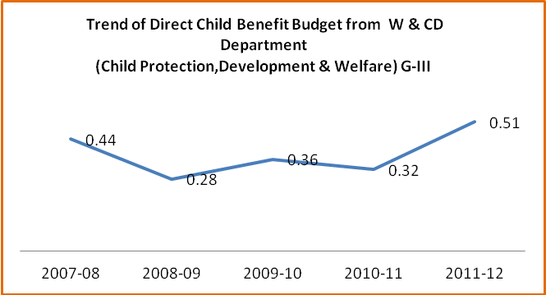
The department of women and child development is considered as the nodal department to take the major stake of child care and development. This department has covered all the scopes of child development through child health and nutrition, child education and child protection and welfare. Moreover, this department has taken lot of initiatives to meet the aforesaid child issues through the direct and indirect interventions having with the budgetary provisions. At the following different graphs and tables are depicted to make it clear over the child budget provisions by the department for the study years.

Graph-III at the above describes about the trend of child benefit budget (direct) from the department of women and child development over financial year 2007-08 to 2011-12. This graph represents the child benefit budget which is based on child protection, development and welfare. From the trend of this graph, it is observed that 0.51% budget of the department is allocated for child protection and development in the year 2011-12 which is the highest percentage of allocation during the five years study period. The lowest 0.28% budget under this component has been spent in the year 2008-09.Table-VIII gives more information on the issue.

Table-VIII
Budget for Child Protection, Development & Welfare from W & CD Department(Rs in Crs)Direct Benefit

Budget Component | 2007-08AE | 2008-09AE | 2009-10AE | 2010-11RE | 2011-12BE
Adoption of Orphan and Destitute Children | 0.005 | 0.002 | 0.005 | 0.01 | 0.01
Campaign, Seminar and Sports | 0.17 | 0.50 | 0.01 | 0.12 | 0.12
Maintenance of Physically Handicapped and Mentally Retarded Children | 0 | 0 | 0 | 0 | 0
Maintenance of Orphan and Destitute Children | 0 | 0.02 | 0 | 0.0001 | 0.0001
Orphanage | 3.46 | 3.22 | 3.93 | 5.30 | 5.30
Integrated Child Protection Schemes | 0.00 | 0.00 | 2.11 | 2.13 | 2.49
Dhanalaksmi-Conditional cash transfer scheme for Girl child with Insurance coverage | 0 | 0 | 0 | 0 | 0
Rajiv Gandhi Scheme for Empowerment of Adolscent Girls | 0 | 0 | 0 | 0 | 4.80
Total Child Component | 3.64 | 3.74 | 6.06 | 7.56 | 12.72
As % of Department Budget | 0.33 | 0.25 | 0.36 | 0.32 | 0.51
Total Budget for W & CD | 1103.56 | 1502.41 | 1686.65 | 2364.96 | 2517.51
Source:-Demand for Grants, Government of Orissa

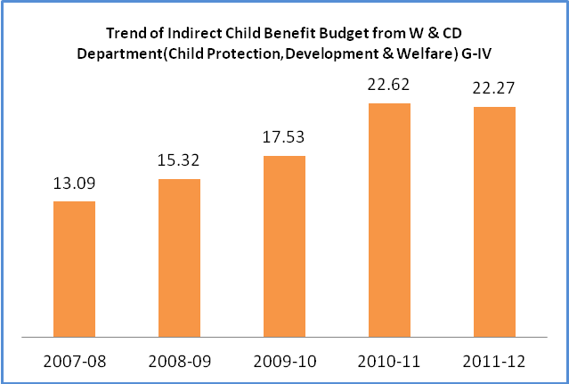
Reflecting on the child benefit budget provisions by the department of women and child development, there are 8 components which are coming out to have direct child benefit budgets during the five years study period. Those components are adoption of orphan and destitute children, campaign, seminar & sports, maintenance to physical handicapped and mental retarded children, maintenance of orphan and destitute children, orphanage, integrate child protection schemes, Dhanalaksmi conditional cash transfer scheme for girl child and Rajiv Gandhi scheme for empowerment of adolescent girl. From the aforesaid components, the two major components like maintenance of handicapped and mental retarded children and Dhanalaxmi conditional cash transfer scheme for girl child have nil budgetary provision all along the study years. Likewise, another significant component Rajiv Gandhi scheme for empowerment of adolescent girls is also having nil budgetary provision from 2007-08 to 2010-11.Budget allocation for maintenance of orphan and destitute children bears no meaning. A haphazard budget allocation for this purpose is being made by the government with the highest amount of Rs 2000/- during the year 2008-09.On the other hand, the government has failed to provide proper justice to destitute and orphan children for their adoption by allocating very negligible budgetary amount throughout the study years i.e Rs 1 lakh during 2010-11 & 2011-12 and Rs 2000/- during 2008-09.
Focusing on the indirect benefit to the children from the budget of the women and child development department, the percentage of budget allocation is going up from the financial year 2007-08 to 2010-11.But during 2011-12, it further diminishes marginally. Graph-IV depicts the visual observation of the above statements. Regarding to the components of indirect benefits, one can better understand the concept at the following table-IX.
Table-IX
Budget for Child Protection, Development & Welfare from W & CD Department(Rs in Crs)Indirect Benefit

Budget Component | 2007-08AE | 2008-09AE | 2009-10AE | 2010-11RE | 2011-12BE
Grants and Assistance(Grants to State Council for Child welfare & voluntary Organisations) | 0.02 | 0.02 | 0.01 | 0.01 | 0.01
Integrated Child Development Service Schemes-District Cell | 2.03 | 2.59 | 2.85 | 8.98 | 6.96
Integrated Child Development Service Schemes | 131.55 | 212.92 | 269.5 | 504.66 | 420.66
Voluntary Organisation for maintenance of physically handicapped and mentally retarded children | 0 | 4.02 | 5.59 | 8.55 | 9.83
Construction of Bal Bhawan | 0 | 0 | 0 | 0 | 0
Rehabilitation of Child in need of care and protection of Javeniles in conflict with law | 0.50 | 0.68 | 0.76 | 1.10 | 0.67
Repair/Addition/Alteration of Anganwadi Centres(Non-Residential Buildings) | 7.00 | 6.41 | 7.00 | 2.00 | 2.30
Construction of Buildings for Anganwadi Centers | 3.39 | 3.57 | 9.65 | 8.88 | 0
State Council for Child Welfare | 0 | 0 | 0.03 | 0.05 | 0.06
Other Plan Schemes for welfare of handicapped(Aid to Voluntary Organisations) | 0.00 | 0.00 | 0.28 | 0.28 | 0.78
State Commission for Protection of Child Rights | 0.00 | 0.00 | 0.00 | 0.43 | 0.43
F.C. award for construction of Anganwadi Centres | 0 | 0 | 0 | 0 | 100.00
Construction of CDPO building | 0 | 0 | 0 | 0 | 13.97
Infrastructure support for renovation of Utkal Balashram | 0 | 0 | 0 | 0 | 5.00
Total Child Component | 144.49 | 230.21 | 295.67 | 534.94 | 560.67
As % of Department Budget | 13.09 | 15.32 | 17.53 | 22.62 | 22.27
Total Budget for W & CD | 1103.56 | 1502.41 | 1686.65 | 2364.96 | 2517.51
Source:-Demand for Grants, Government of Orissa
Over the indirect child benefit budget from the department of school and mass education, it is observed that the percentage of indirect child benefit budget increases from 2007-08 to 2010-11 (table-IX) i.e 13.09%-2007-08 to 22.62%-2011-12.But looking at the detail components of indirect child benefit budget on protection, development and welfare, there are 14 components which are coming out from the scrutiny. Some of the major components of that scrutiny are finance commission award for construction of AW centres, state commission for protection of child rights, state council for child welfare, repair of AW centres, construction of Bal Bhawan, Construction of buildings of AW centre and etc. From those above components, the components of FC award for construction of AW centres, Construction of CDPO building and support for renovation of Utkal Balashram have nil budgetary allocation since 2007-08 to 2010-11.Likewise, there is no budgetary support for construction of AW centre during the year 2011-12 when majority of AW centres across the state are running in rented houses or without buildings. The details of the other components can be conceptualised by go through the table.

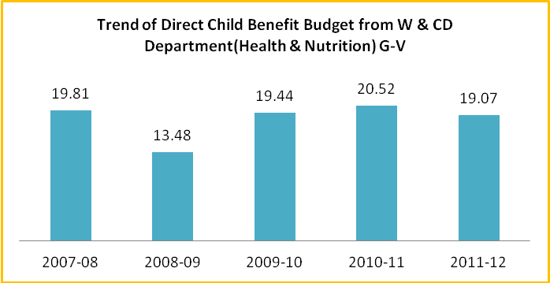
Describing about the issues of health and nutrition, it is observed from the graph-V that percentage of direct child benefit budget from the department budget (W & CD) is marked to be impressive. It is seen that during 2007-08 percentage of budget allocation towards health and nutrition is around 20% which reaches at 19% in the year 2011-12.Lookig at the trend of budget allocation for health and nutrition, it gives less fluctuating scenario as compared to other fields of budget allocation. For more details, one can go through the table at the following.
Table: X Budget for Child Health & Nutrition from W & CD Department(Rs in Crs)Direct Benefit

Budget Component | 2007-08AE | 2008-09AE | 2009-10AE | 2010-11RE | 2011-12BE
Nutrition for adolocent girls | 5.89 | 2.74 | 3.90 | 0 | 0
Supplementary Nutrition Programme | 188.27 | 197.56 | 324.05 | 485.24 | 480.00
Reduction of Child Malnutrition and Child Mortality | 2.01 | 2.28 | 0 | 0 | 0
Special Programme for KBK districts for reduction of Child Malnutrition and Child Mortality | 2.24 | 0 | 0 | 0 | 0
Special Programme for KBK districts for emergency feeding program | 20.22 | 0 | 0 | 0 | 0
Total Child Component | 218.63 | 202.58 | 327.95 | 485.24 | 480.00
As % of Department Budget | 19.81 | 13.48 | 19.44 | 20.52 | 19.07
Total Budget for W & CD | 1103.56 | 1502.41 | 1686.65 | 2364.96 | 2517.51
Source:-Demand for Grants, Government of Orissa
As per table-X, it is observed that there is very negligible amount of budget allocation for child health and nutrition both for the components on special programme for KBK districts for reduction of child malnutrition and mortality as well as special programme for KBK districts for emergency feeding programme during the year of 2007-08. But thereafter no budgetary allocation is found on these components for the rest of the study years. Moreover, the most important fact is about nil budgetary provision towards reduction of child malnutrition and mortality since 2009-10 and on wards when Odisha occupies very high rank place at child malnutrition and mortality in the Indian union.
Table: XI Budget for Child Health & Nutrition from W & CD Department(Rs in Crs)Indirect Benefit
Budget Component | 2007-08AE | 2008-09AE | 2009-10AE | 2010-11RE | 2011-12BE
Mobility support to Anganwadi workers & ANM for reduction of Infant Mortality | 0.44 | 0.30 | 0 | 0 | 0
Special Programme for KBK districts for mobility support to Anganwadi workers & ANM for reduction of Infant mortality. | 0.56 | 0 | 0 | 0 | 0
Total Child Component | 1.00 | 0.30 | 0 | 0 | 0
As % of Department Budget | 0.09 | 0.02 | 0.00 | 0.00 | 0.00
Total Budget for W & CD | 1103.56 | 1502.41 | 1686.65 | 2364.96 | 2517.51
Source:-Demand for Grants, Government of Orissa

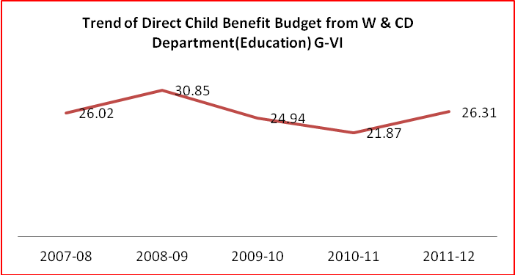
Looking at the indirect child benefit on health and nutrition from the W & CD budget (table-XI), it is observed that there is nil budgetary provision for the budget component on special programme for KBK districts for mobility support to Anganawadi workers and ANM for reduction of infant mortality. At the same time, there is very negligible amount of budget allocation for mobility support to Anganawadi Workers and ANM for reduction of infant mortality over the years of 2007-08 and 2008-09 while the rest of the years go for nil budgetary provision on the said component. Therefore, the study finds very negligible percentage (0.09%-2007-08, 0.02%-2008-09) of budget allocation on child health and nutrition (indirect child benefit) from the department budget for the first two years, followed by nil budgetary provision for the rest of years.
Graph-VI depicts about the trend child budget percentage for education (direct benefit) from the department of women and child development. It seen during the year of 2008-09 that percentage of budget allocation for child education from the department budget is around 31% which is the highest score. At the subsequent period it declines to 22% in the year 2010-11 and reaches at 26.31% in the year 2011-12.This signifies a healthy trend of child benefit budget for education from the department of women and child development.
Table: XII Budget for Child Education from W & CD Department(Rs in Crs)Direct Benefit
Budget Component | 2007-08AE | 2008-09AE | 2009-10AE | 2010-11RE | 2011-12BE
Mid-Day Meals | 287.10 | 463.42 | 415.26 | 505.08 | 638.00
Printing of Braille Books | 0.02 | 0.02 | 0.03 | 0.03 | 0.03
Providing cycles to School going ST/SC Girls | 0 | 0 | 4.92 | 11.70 | 0.00
Providing cycles to School going BPL Girls | 0 | 0 | 0 | 0 | 0
Scholarship and Stipend to Handicapped Students | 0 | 0 | 0.38 | 0.50 | 24.31
Total Child Component | 287.12 | 463.44 | 420.59 | 517.31 | 662.34
As % of Department Budget | 26.02 | 30.85 | 24.94 | 21.87 | 26.31
Total Budget for W & CD | 1103.56 | 1502.41 | 1686.65 | 2364.96 | 2517.51
Source:-Demand for Grants, Government of Orissa
By looking in to the detail analysis of direct child benefit budget from the department of women and child development(table-XII), it is observed that there is nil budgetary provision on the budget component of providing cycles to school going BPL girls while for the SC & ST girls it is nil for the year 2011-12.Focusing on the scholarship and stipend to the handicapped students, it is found to be significant for the year of 2011-12.Budget allocation for printing of Braille Books for blind children looks to be insufficient all along the study years.
Table:XIII Budget for Child Education from W & CD Department(Rs in Crs) Indirect Benefit
Budget Component | 2007-08AE | 2008-09AE | 2009-10AE | 2010-11RE | 2011-12BE
Training of Teachers for the blind and disabled | 0.05 | 0.04 | 0.05 | 0.16 | 0.06
As % of Department Budget | 0.0045 | 0.0027 | 0.0030 | 0.0068 | 0.0024
Total Budget for W & CD | 1103.56 | 1502.41 | 1686.65 | 2364.96 | 2517.51
Source:-Demand for Grants, Government of Orissa
Over the issue of indirect child benefit budget for education from the department of women and child development, it is observed from table-XIII that percentage of budget allocation from the department budget is very much insignificant. Only one budget head that is training of teachers for the blind and disabled is dictated among various components. This component contains budgetary allocation of Rs 16 lakhs during 2010-12 as the highest amount which slides down to Rs 6 lakhs at the next year (2011-12). The details can be observed from the table.
3.2.1. Off Budget for Child Welfare
Table: XIV Off Budget Provision for Child Development & Welfare(Rs in Crs)
Dhanalaxmi conditional cash transfer scheme for Girl with Insurance Coverage | 2007-08AE | 2008-09AE | 2009-10AE | 2010-11AE | 2011-12BE
Total Budget | 0 | 0 | 0.73 | 2.23 | NA
Source:-Orissa Budget at a Glance 2011-12
As per table- XIV, budgetary provision for Dhanalaxmi conditional cash transfer scheme for girls with insurance coverage from the off budget sources is found to be positive over the financial year 2009-10 and 2010-11 which is Rs 73 lakhs and Rs 2.23 crores respectively. But looking at the government side, there is found to be nil budgetary provision under the component as described in the earlier table.
3.3. Health and Family Welfare Department

The department of health and family welfare is one the key departments of the government. This department is mainly responsible for good health and standard of living of people of the state. The intervention of this department is very technical and strategized all over the state. Through this strategized interventions, the department has been trying the level best to provide all sort of health services at the doorstep of the people. However, the department has some specific health services which are focused to maximum benefits to the mother and child. In this context, the study has tried to track the child benefit budget components of the department to know the magnitude of budget benefiting to the children over the five years of study period.
The graph and table at the following depicts the matter lucidly.

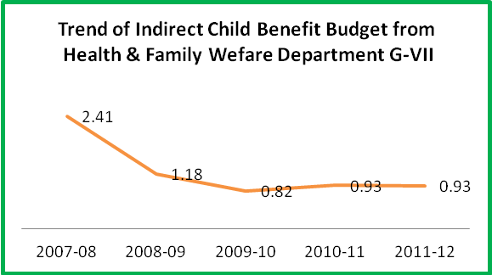
As observed during the budget analysis that department of health and family welfare has no direct budgetary provision for child benefit. But looking at the trend of indirect budgetary provision for children, it seems to be declining over the study years. As per graph-VII, the percentage of budget allocation for child benefit during 2007-08 is 2.41% which declines to 0.82% in 2009-10.But, in the next year (2010-11), it further revives and reaches at 0.93%.The same figure is also found in 2011-12.The details about the indirect child benefit budget provisions from the department of health and family welfare are described in table-XV
Table: XV Budget for Direct Child Benefit from Health & Family Welfare Department(Rs in Crs)
Component | 2007-08 AE | 2008-09 AE | 2009-10 AE | 2010-11RE | 2011-12 BE
Institute of Paediatrics, Cuttack | 14.03 | 6.29 | 5.41 | 9.00 | 8.31
Infant mortality reduction under Child Survival and safe Motherhood Programme | 1.01 | 1.30 | 0 | 0 | 0
Maternity and child welfare Centres | 2.22 | 3.06 | 3.88 | 5.22 | 5.12
Total Child Component | 17.26 | 10.65 | 9.29 | 14.22 | 13.43
As % of Department Budget | 2.41 | 1.18 | 0.82 | 0.93 | 0.93
Total Budget for Health & family Welfare | 715.31 | 899.13 | 1132.49 | 1522.17 | 1451.66
Source:-Demand for Grants, Government of Orissa
As per table-XV, there is no budgetary allocation for infant mortality reduction under the head of child survival and safe motherhood programme for the year of 2009-10, 2010-11 and 2011-12 which is a key component of child welfare for the department of health and family welfare. Besides whatever amount of budget has been allocated for the first two years (2007-08-Rs 1.01Crs & 2008-09-Rs 1.30Crs) seems to be inadequate by looking in to the infant and mother mortality rate in the state. Institutional budget allocation for child and mother care is also at reduced amount in 2011-12 as compared to the previous year when more number of paediatrics and pregnant patients are going up at the health centres.Further, it comes out from the table that the amount of total budget for child benefit (indirect) from the health and family welfare department is found to be less in 2011-12(Rs13.43crs) as compared to the previous year 2010-11(Rs 14.22Crs)
3.3.1. Off Budget for Immunisation and Reproductive Child Health
Besides the budgetary support by the state government for health sector intervention, there are some other sources which also add their budget support to strengthen this intervention. As a part of this process, the central government supports to state government for the activities of different immunisations and Reproductive Child Health programmes. The table at the following depicts the off budget provision for child health elaborately.
Table: XVI Off Budget for Immunization and Reproductive Child Health (Rs in Crs)
 | 2007-08 AE | 2008-09 AE | 2009-10AE | 2010-11AE | 2011-12BE
Routine Immunization Programme | 3.72 | 4.17 | 5.81 | 4.66 | NA
As % of total Exp | 4.05 | 3.94 | 3.89 | 4.07
Immunization | 0 | 0 | 6.21 | 0 | NA
As % of total Exp | 0 | 0 | 4.16 | 0
Pulse Polio | 0 | 0 | 0 | 0 | NA
As % of total Exp | 0 | 0.00 | 0.00 | 0.00
Reproductive Child Health(Ph-II) | 88.15 | 101.79 | 137.34 | 109.85 | NA
As % of total Exp | 95.95 | 96.06 | 91.95 | 95.93
Total Expenditure | 91.87 | 105.96 | 149.37 | 114.51 | NA
Source: Orissa Budget at a Glance 2011-12
As per the table-XVI, the component of reproductive child health has the major percentage of expenditure from the total amount of off budget provision for child health. It is observed about 96% of expenditure from the off budget provision of child health is spent towards reproductive child health for most of the study years. Off budget expenditure for immunisation is very minimal about 4% in the 2009-10 while other years for this purpose have no expenditure. Simultaneously, there is no off budget expenditure for pulse polio during the entire study period.
3.4. STs & SCs Development and Minorities & Backward classes Welfare Department
The department of scheduled castes and scheduled tribes development is directly or indirectly engaged for development and welfare of the children through its budgetary provision. The department through its schools provides education to the children of scheduled castes and scheduled tribes. Apart from, this department also provides incentives in various forms to children of scheduled castes, scheduled tribes, other backward classes and minorities to bring them in to the schools. The details of child benefit budget provision by the department of SC & ST Development can be observed from the following graph and table.
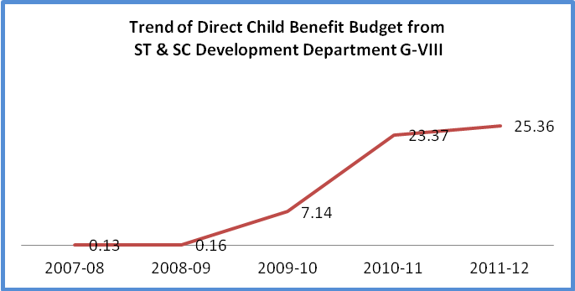
It is seen from graph-VIII that the trend of budget allocation for education to the children of scheduled castes, scheduled tribes, other backward classes and minority is increasing all along the study years which is the percentage of child budget component(direct benefit) from the department of SC & ST development. It is seen that in 2007-08, only 0.13% was the child budget component from the budget of the SC & ST development which reaches at 25.36% in the year of 2011-12.The detail of the child budget component from SC & ST development department can be available at the table-XVII.
Table: XVII Budget for Direct child Benefit from ST & SC Development Department(Rs in Crs)
Component | 2007-08 AE | 2008-09 AE | 2009-10 AE | 2010-11RE | 2011-12 BE
Supply of Bicycles to Girls students | 0.81 | 1.12 | 0 | 0 | 0
Pre-matric scholarship for OBC students | 0 | 0 | 1.00 | 0.54 | 0.0002
Pre-matric scholarship for Minority students | 0 | 0 | 0.37 | 1.24 | 2.00
Scholarship and Stipend for SC Students | 0 | 0 | 6.38 | 58.18 | 53.92
Scholarship and Stipend for ST Students | 0 | 0 | 53.82 | 197.07 | 270.32
Total Child Component | 0.81 | 1.12 | 61.57 | 257.03 | 326.24
As % of Department Budget | 0.13 | 0.16 | 7.14 | 23.37 | 25.36
Total Budget for ST & SC Development Department | 605.33 | 692.2 | 862.25 | 1099.72 | 1286.33
Source:-Demand for Grants, Government of Orissa
Table-XVII depicts about the direct benefit to children by the department of SC & ST development. It is observed that pre-matric scholarship for OBC children declines sharply to Rs 2000/- in the year 2011-12 from Rs 1crore during 2009-10.Likewise, there is nil budgetary provision for distribution of cycles to girl children since 2009-10 to 2011-12 which seems to be unjustified on the wake no communication facility for the girl children to arrive at the school in time. Budget provision for other components can be understood from the table.
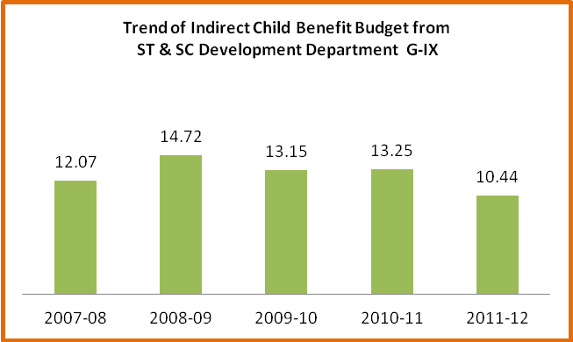
As a part of indirect benefits to children by the department of SC & ST development, it looks that the trend of benefits to the children is much fluctuating which is significantly reduced in the year 2011-12.As per graph-IX,the highest percentage of child benefit(indirect) from the departmental budget provision is around 15% in the year 2008-09 which sharply reduced to 10.44% for the year of 2011-12.The details of indirect child benefit budget provision from the department of SC and ST development are described at table-XVIII.

Table:XVIII Budget for Indirect Child Benefit from ST & SC Development Department(Rs in Crs)
Component | 2007-08 AE | 2008-09 AE | 2009-10 AE | 2010-11 RE | 2011-12 BE
Ashram School | 9.59 | 34.04 | 30.00 | 38.20 | 17.25
Sevashrams | 33.60 | 46.13 | 60.75 | 77.72 | 76.98
Special Educational Infrasturcture | 4.74 | 1.72 | 2.56 | 4.84 | 10.00
Maintenance/ special repair/Addition/Alteration/Renovation of School and Hostel buildings of ST & SC Dev. Department (Non-Res.Buldings) | 25.14 | 20.00 | 20.00 | 25.00 | 30.00
Promotion of Sports (Archery Training Center in Nodal Schools) | 0 | 0 | 0.10 | 0 | 0
Total Child Component | 73.07 | 101.89 | 113.41 | 145.76 | 134.23
As % of Department Budget | 12.07 | 14.72 | 13.15 | 13.25 | 10.44
Total Budget for ST & SC Development Department | 605.33 | 692.2 | 862.25 | 1099.72 | 1286.33
Source:-Demand for Grants, Government of Orissa
As per the above table, there is no budgetary allocation for promotion of sports (Archery training Centrer in nodal schools)in tribal schools except very nominal budgetary allocation of Rs 10 lakhs for the year of 2009-10.Budget allocations for Ashram and Sevashram Schools are also found in reduced amount for financial year 2011-12 as compared to the previous year 2010-11(Ashram School Rs 38.20 crores-2010-11 & Rs 17.25 crores-2011-12,Sevashram School Rs 77.72 crores-2010-11 & Rs 76.98 crores-2011-12.
3.5 Sports & Youth Services Department
The department of Sports and Youth Services deals with the improvement of sports activities in the state. As a part of these activities, it has indirect budgetary provision for development of sports skill of children of the state which are discussed at the following graph and table.
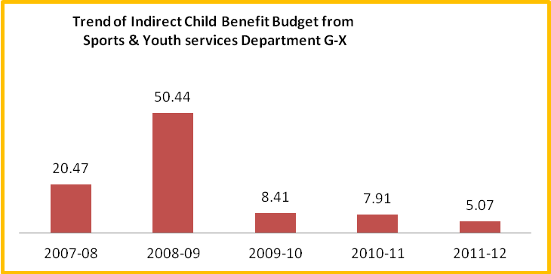
Graph-X at the below depicts about the trend of budgetary allocation from the department allocation of sports and youth services towards indirect benefit of children for sports in percentages. As per the graph, it is observed that the percentage of budget allocation for children benefit reduces sharply since 2008-09 when it was more than 50% of the department budget.But, from 2009-10 to 2011-12,the percentage of budget allocation is very nominal i.e 8.41% in 2009-10,7.91% in 2010-11 & 5.07% in 2011-12.The details of child budget component can be observed at table-XIX.
Table: XIX
Budget for Indirect Child Benefit from Sports and Youth Services Department(Rs in Crs)
Component | 2007-08AE | 2008-09AE | 2009-10AE | 2010-11RE | 2011-12BE
Grants for Participation of Orissa state school Team in National Game | 0.01 | 0.03 | 0 | 0.01 | 0.01
Grants to School Games Federation | 0 | 0 | 0 | 0 | 0
Purchase of Sports Goods | 0.20 | 0.21 | 0.15 | 0.16 | 0.21
Development of Play Fields | 1.06 | 10.00 | 1.65 | 1.36 | 1.00
Sports equipment support to Blocks/ Gram punchyats | 1.00 | 4.19 | 0.52 | 1.00 | 0.75
Total Child Component | 2.27 | 14.43 | 2.32 | 2.53 | 1.97
As % of Department Budget | 20.47 | 50.44 | 8.41 | 7.91 | 5.07
Total Budget for Sports & Youth Services Department | 11.09 | 28.61 | 27.58 | 31.99 | 38.85
Source:-Demand for Grants, Government of Orissa
As per the table-XIX, it is observed that there is nil budgetary allocation for the budgetary component grants to school games federation all along the study years. Besides, very negligible amount of budget has been found for purchase of sports goods during the entire study period. Likewise budgetary spending and allocations for the components of development of play fields and sports equipment support to block and gram panchayats are not sufficient which can be observed at the table.
3.6 Labour & Employment Department
The department of Labour & Employment has tremendous role in the welfare of the children of the state. This department by the help of child labour regulation act has saved thousands of children against different form of exploitation all over the state. The detail about the trend of budgetary support in favour of child benefit is depicted in the graph-XI.
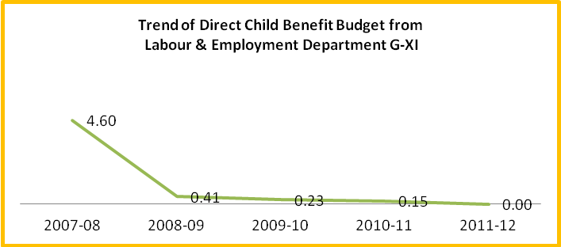
As per the graph, the trend of budget allocation for child benefit component from the department budget of labour and employment describes about the declining percentage all over the study years. It is seen that 4.60% of child benefit budget was spent in 2007-08 from the total amount of the department budget. However, in the subsequent years, this percentage reduces constantly and reaches at nil budgetary provision in the year 2011-12.For more detail on the issue, one can observe the table at the following.
Table: XX
Budget for Direct Child Benefit from Labour and Employment Department (Rs in Crs)
Component | 2007-08AE | 2008-09AE | 2009-10AE | 2010-11RE | 2011-12BE
Implementation of Child Labour (Prohibition and Regulation) Act, 1986 | 1.82 | 0.19 | 0.14 | 0.15 | 0.00
As % of Department Budget | 4.60 | 0.41 | 0.23 | 0.15 | 0.00
Total Budget for Labour & Employment Department | 39.58 | 46.89 | 61.76 | 100.24 | 65.56
Source:-Demand for Grants, Government of Orissa
Table-XX, describes about the budgetary provision on the child budget component of implementation of child labour (prohibition and regulation) act from total department budget provisions during the study period. It is seen from the table that the amount of budget allocation for implementation of child labour act 1986 reduces constantly all along the study years besides a slight deviation in the year 2010-11 where marginal amount of budget hike has been made on the said component. Apart from, there is no other components in the department which are directly or indirectly providing benefits to the children in the state.
3.7 Works Department
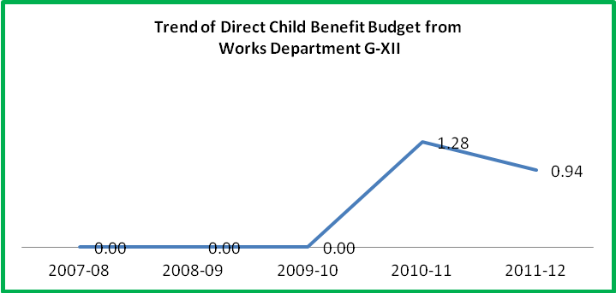
The department of works is an important department for rural infrastructure construction and development. As a part of holistic objective, this department has a obligatory responsibility for child development in the form of repair and renovations of government schools and colleges. At the following graph-XII depicts the fact through visual presentation.
As per the graph, the trend of percentage of budget allocation for child budget component from the department budget provisions is found to be positive after nil budgetary provision from 2007-08 to 2009-10.But, this trend is falling down during the budget provision in 2011-12 as compared to the previous year budget (1.28%-2010-11).For more details, table-XXI can be explored.
Table: XXI Budget for Direct Child Benefit from Works Department (Rs in Crs)
Component | 2007-08AE | 2008-09AE | 2009-10AE | 2010-11RE | 2011-12BE
Repair & Renovation of 50 years old Govt. School and College building | 0 | 0 | 0 | 22.00 | 20.00
As % of Department Budget | 0.00 | 0.00 | 0.00 | 1.28 | 0.94
Total Budget for Works Department | 1031.25 | 1541.43 | 1405.49 | 1717.73 | 2130.38
Source:-Demand for Grants, Government of Orissa
Child benefit budget under the department of works is very much confined under one head which is called repair and renovation of 50 years old government school and college buildings. As per the table, amount of budget allocation on the aforesaid head is nil for the financial year 2007-08.2008-09 and 2009-10.But,during the year of 2010-11,this component receives RS 22 crores and gets down to Rs 20 crores in the next year.
3.8. Tourism & Culture Department
The contribution of department of tourism and culture is very crucial and significant in exposing child potentiality and building up their career in the field of art and dance. Therefore, it is important for the department to have child budget components constantly in the departmental budgetary provision for greater interest of the children as well as the state. The details about the departmental budgetary provision for child benefits are described at following graph and table.
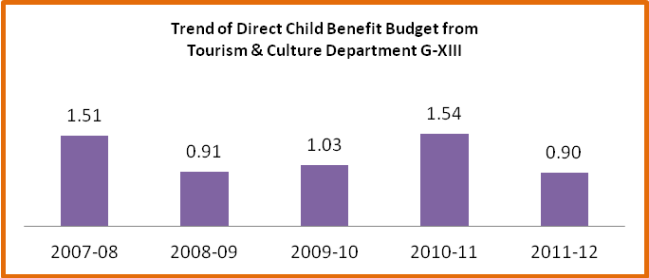
As per the graph-XIII, the percentage of budget allocation for child benefit from the departmental budget provisions is very much fluctuating all along the study years. It is seen that during the year of 201-11,the percentage of budget allocation was highest i.e 1.54% which reduces to 0.90% in the next year(2011-12).Looking at the overall budgetary provision on this component, it seems to be less and inadequate. For more details, one can go through the table-XXII.

Table: XXII
Budget for Indirect Child Benefit from Tourism & Culture Department (Rs in Crs)
Component | 2007-08AE | 2008-09AE | 2009-10AE | 2010-11RE | 2011-12BE
Grants for Establishment of music school | 0.05 | 0.03 | 0.09 | 0.10 | 0.10
Grants for Rural Libraries | 0.70 | 0.75 | 0.75 | 0.75 | 0.75
Grants to Dance and Music Schools of the state | 0.02 | 0.02 | 0.02 | 0.02 | 0.03
Total Child Component | 0.77 | 0.80 | 0.86 | 0.87 | 0.88
As % of Department Budget | 1.51 | 0.91 | 1.03 | 1.54 | 0.90
Total Budget for Tourism & Culture Department | 50.91 | 87.94 | 83.82 | 56.45 | 98.11
Source:-Demand for Grants, Government of Orissa
Table-XXII, finds about three child benefit budget components under the department of tourism and culture. Those components are grants for establishment of music school, grants for rural libraries and grants to dance & music schools of the state. But, it is seen that except the component of grants for rural libraries, no other components have properly been emphasised where the children have much interest to develop their potentialities.
3.9. Child Benefit Budget Overall
At the above, departments contributing budget for child education, health and nutrition and child development, protection and welfare are discussed in detail but the tables and graphs at the following put compressive reflection on the overall budget allocation from departmental and off budget sources of child benefit including sector wise allocations. it also has been explored the share of total departmental budget expenditure for child benefit from the state budget expenditure and Gross State Domestic Production (GSDP) of different study years.
Table: XXIII Budget for Child Benefit from Departmental Sources(Rs In Crs)
Department | 2007-08AE | 2008-09AE | 2009-10AE | 2010-11RE | 2011-12BE
S & ME Department | 13.72 | 17.69 | 22.45 | 34.76 | 66.04
As % of Total Budget | 1.79 | 1.69 | 1.78 | 1.72 | 2.90
W & CD Department | 654.93 | 900.31 | 1050.32 | 1545.21 | 1715.79
As % of Total Budget | 85.66 | 85.98 | 83.33 | 76.40 | 75.30
Health Family Welfare Department | 17.26 | 10.65 | 9.29 | 14.22 | 13.43
As % of Total Budget | 2.26 | 1.02 | 0.74 | 0.70 | 0.59
SC & ST Development Department | 73.78 | 103.01 | 174.98 | 402.79 | 460.47
As % of Total Budget | 9.65 | 9.84 | 13.88 | 19.92 | 20.21
Sports & Youth Services Department | 2.27 | 14.43 | 2.32 | 2.53 | 1.97
As % of Total Budget | 0.30 | 1.38 | 0.18 | 0.13 | 0.09
Labour & Employment Department | 1.82 | 0.19 | 0.14 | 0.15 | 0
As % of Total Budget | 0.24 | 0.02 | 0.01 | 0.01 | 0
Works Department | 0 | 0 | 0 | 22.00 | 20.00
As % of Total Budget | 0 | 0 | 0 | 1.09 | 0.88
Tourism & Culture Department | 0.77 | 0.80 | 0.86 | 0.87 | 0.88
As % of Total Budget | 0.10 | 0.08 | 0.07 | 0.04 | 0.04
Total Budget | 764.55 | 1047.08 | 1260.36 | 2022.53 | 2278.58
Source:-Demand for Grants, Government of Orissa
As per table-XXIII, the total departmental expenditure for child benefit is increasing over the study years which indicate very positive symptom of the government towards addressing various issues of children in the state. In the year of 2007-08, the total departmental expenditure for child benefit was Rs 764.55 Crores which has gone up to Rs 2278.58 Crores during 2011-12.Looking at the departmental contribution to the total child benefit budget, it is the women and child development department which has the major stake of expenditure, followed by the department of ST & SC development, School & Mass Education department and Health & Family Welfare department. Though other departments are having child component budget expenditures but their shares to the total child benefit budget are not significant and sustainable. From the above table, it is observed that the department of W & CD shares 80% and more of child budget expenditure for the first three years of study period from total child budget allocations followed by 75% in the next two years of the study period. Next to the department of W & CD, it is the ST & SC Development department bears 10% to 20% of expenditure from the total child benefit budget over the five years of study period. Likewise, the share of other departments from the total child benefit budget can be perceived from the table.
Table: XXIV Budget for Child Benefit from Off Budget Sources(Rs in Crs)
 | 2007-08AE | 2008-09AE | 2009-10AE | 2010-11AE | 2011-12AE
OFF Budget for Education | 839.44 | 883.01 | 171.78 | 852.58 | NA
As % of Total Budget | 90.14 | 89.29 | 53.37 | 87.96
OFF Budget for Child Welfare & Development  (Dhanalaxmi Conditional Cash Transfer Scheme for Girls Child With Insurance Coverage) | 0 | 0 | 0.73 | 2.23 | NA
As % of Total Budget | 0 | 0 | 0.23 | 0.23
OFF Budget for Child Health(Immunisation & Reproductive Child Health | 91.87 | 105.96 | 149.37 | 114.51 | NA
As % of Total Budget | 9.86 | 10.71 | 46.41 | 11.81
Total Budget | 931.31 | 988.97 | 321.88 | 969.32 | NA
Source:-Orissa Budget at a Glance 2011-12
Table-XXIV describes about the off budget provision towards child benefit in the state. It is observed from the table that highest percentages of off budget expenditures have been borne in education sector, followed by child health and child welfare and development. As per the table, there has been more than 88% of the total off budget provision has been spent for child education for maximum number of the study years (excluding 2009-10). On the contrary, 10%-12% expenditure has been recorded for child health from the total off budget provision except 2009-10 budget shares. Expenditure for child welfare and development from off budget provision is very nominal and haphazard. The off budget data of child benefit for 2011-12 is not available from budget at a glance.
Table: XXV Budget for Child Benefit from Departmental & Off Budget Sources(Rs in Crs)

Source | 2007-08AE | 2008-09AE | 2009-10AE | 2010-11 | 2011-12
Departmental | 764.55 | 1047.08 | 1260.36 | 2022.53 | 2278.58
As % of Total Budget | 45.08 | 51.43 | 79.66 | 67.60
Off Budget | 931.31 | 988.97 | 321.88 | 969.32 | NA
As % of Total Budget | 54.92 | 48.57 | 20.34 | 32.40
Total Budget | 1695.86 | 2036.05 | 1582.24 | 2991.85 | 2278.58
Source:-Demand for Grants and Orissa Budget at a Glance 2011-12
Table-XXV is much important to gather information on the total budget allocation for child benefits from both the off and departmental sources during the study years. Apart from, it also focuses on the share of budget contribution (off & departmental) to the total amount of child benefit budget. As per the table, the amounts of child benefit budget from off and departmental sources are increasing over the study years except 2009-10(Rs 1582.24 Crs).But looking at the share of departmental and off budget provisions from the total expenditure, it seems to be the share of off budget is more than the departmental provision(0ff budget-54.94%,Departmental-45.08%) in 2007-08.Apart from, the percentages of department budget provision are more than the off budget sources for rest of the study years.
Table: XXVI Sector wise Child Benefit Budget from Off & Departmental Sources(Rs in Crs)
Sector | 2007-08AE | 2008-09AE | 2009-10AE | 2010-11 | 2011-12*
Education | 1214.11 | 1467.19 | 789.85 | 1829.6 | 1208.91
As % of Total Budget | 71.59 | 72.06 | 49.92 | 61.15 | 53.06
Health & Nutrition | 328.76 | 319.49 | 486.61 | 613.97 | 493.43
As % of Total Budget | 19.39 | 15.69 | 30.75 | 20.52 | 21.66
Child Protection, Development & welfare | 152.99 | 249.37 | 305.78 | 548.28 | 576.24
As % of Total Budget | 9.02 | 12.25 | 19.33 | 18.33 | 25.29
Total Budget | 1695.86 | 2036.05 | 1582.24 | 2991.85 | 2278.58
*Note: Budget for 2011-12 does include Off budget amount due to non availability of data
Source:-Demand for Grants and Orissa Budget at a Glance 2011-12

Table XXVI depicts about the sector wise budget allocations from off and departmental sources. As per the table, the total budget expenditures for various sectors from the off and departmental sources are increasing all along the study years except 2009-10.It is observed from the table that the maximum percentage of budget expenditure from the total child benefit budget has been spent for education, followed by health and nutrition and child protection, development & welfare. It is 50%-72% of expenditure comes under the education sector, followed by 16%-31% for health & nutrition and 9%-25% for child protection, development & welfare.
Table: XXVII Sector wise Departmental Child Benefit Budget as % of State Exp & GSDP

Sector | 2007-08AE | 2008-09AE | 2009-10AE | 2010-11RE | 2011-12BE
Education | 374.77 | 584.18 | 618.07 | 977.02 | 1208.91
As % State Exp | 1.64 | 2.17 | 2.02 | 2.48 | 2.69
As % of GSDP | 0.29 | 0.41 | 0.38 | 0.52 | 0.56
Health & Nutrition | 236.89 | 213.53 | 337.24 | 499.46 | 493.43
As % State Exp | 1.04 | 0.79 | 1.10 | 1.27 | 1.10
As % of GSDP | 0.19 | 0.15 | 0.21 | 0.27 | 0.23
Child Protection, Development & welfare | 152.99 | 249.37 | 305.05 | 546.05 | 576.24
As % State Exp | 0.67 | 0.93 | 1.00 | 1.39 | 1.28
As % of GSDP | 0.12 | 0.17 | 0.19 | 0.29 | 0.27
Total State Budget | 22844.33 | 26922.86 | 30540.64 | 39388.72 | 44878.97
GSDP | 127234 | 142728 | 162327 | 186356 | 214309
Source:-Demand for Grants, Government of Orissa
Reflecting on table XXVII, it shows about the departmental expenditure for child benefit under different sectors. As per the table, the maximum amount of budget from the total departmental expenditure is spent for the education sector, followed by the other two sectors (almost nearer to same). The table also depicts about the sector wise percentages of expenditure from the total state expenditure and GSDP which can be better understood at the following three graphs.
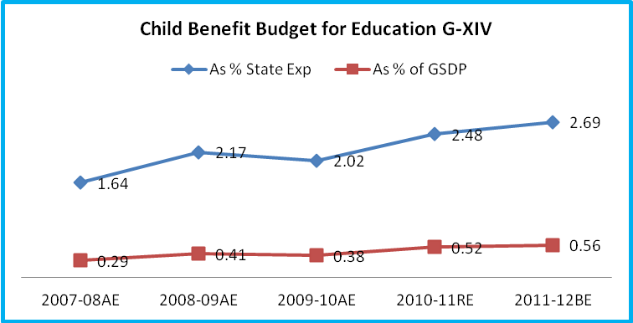
As per the graph-XIV, the trend of child benefit budget for education from the state expenditure is increasing since 2009-10 and onwards i.e 2.02% in 2009-10 which goes up to 2.48% in 2010-11 & 2.69% in 2011-12.Likewise, percentage of education expenditure from the GSDP is also increasing from 2009-10 to 2011-12 i.e 0.38% in 2009-10 and arrived at 0.56% in 2011-12.
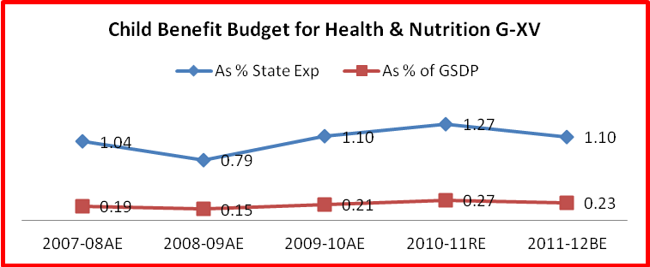
Focusing on the trend of graphical presentation of child benefit budget for health and nutrition from the state expenditure and GSDP, it depicts about the declining trend of expenditure during financial year 2011-12 as compared to the previous year (2010-11).As per the graph-XV, the percentage of expenditure for health and nutrition from the state expenditure increases from 2008-09 to 2010-11 i.e from 0.93% to 1.39%.But,during the year 2011-12 it decreases to 1.10%.Similarly,child health budget expenditure from GSDP also increases at the corresponding trend with the state budget expenditure as explained earlier.
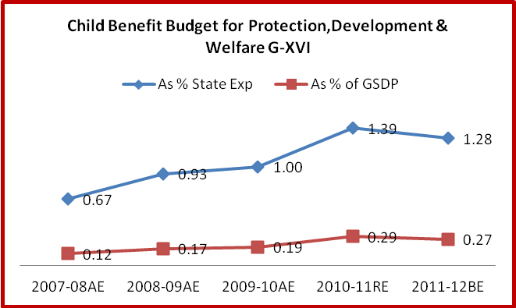
Like the above two graphical presentations on child education and health & nutrition, graph-XVI represents the share of child budget expenditure from the total state budget and GSDP for child protection, development and welfare. As per the graph, the percentage of child benefit budget from the state expenditure for the aforesaid purposes decreases during 2011-12 as compared to the previous year 2010-11 i.e 1.39%(2010-11) to 1.28%(2011-12).On the other hand, this purpose of expenditure from the state budget shows an increasing trend since 2007-08 to 2009-10(2007-08-0.67%,2008-09-0.93% & 2011-12-1.00%).Similarly, the trend of child budget expenditure from the GSDP also increases from 2007-08 to 2010-11,after that it diminishes to 0.27% in 2011-12.
Table-XXVIII Departmental Budget for Child Benefit from the State Expenditure & GSDP(Rs in Crs)

Source | 2007-08AE | 2008-09AE | 2009-10AE | 2010-11RE | 2011-12BE
Departmental Exp for Child Benefit | 764.55 | 1047.08 | 1260.36 | 2022.53 | 2278.58
Total State Budget | 22844.33 | 26922.86 | 30540.64 | 39388.72 | 44878.97
GSDP | 127234 | 142728 | 162327 | 186356 | 214309
Deptt. Exp as % of State Exp | 3.35 | 3.89 | 4.13 | 5.13 | 5.08
Deptt. Exp as % of State Exp | 0.60 | 0.73 | 0.78 | 1.09 | 1.06

The table (XXVIII) at the above depicts about the share of child budget from the total state expenditure and Gross State Domestic Production. As per the table, the percentages of budget expenditure from the total state expenditure and GSDP for child benefit are increasing steadily during all the study years except 2011-12. This indicates about the seriousness of the government on various child issues in the state through financial terms.

Conclusion

Budget in lay man’s language refers to an exercise of income and expenditure of the government over a specific period of time. Though each individual is governed by the budget at every step of life but he is ignored about it. At every moment of time, he is more or less affected by the dynamics of budget. But, with the lack of scope and knowledge, the common man has to admit the market mechanism as a spontaneous process instead of human made events. The budget of the government is principally responsible for the well being of citizens of the country. However, the budget of our state or country follows a close door process where the bureaucrats and ministers are involved in it. The common men do not find any scope to hold up their views in the budget making process of the state or the nation. Therefore, the wills of the bureaucrats and politicians are levied on the citizens of the country through the budget mechanism. The most significant issue is about the budget for the citizens which are far from their actual need. In this context, the provisions of budget become unrealistic and illogical. It has been observed on many heads of different departments that in spite of less significance, there is too much of budget allocations and vice versa. This is only happening due to non participation of common men during the budget making process.
Over the issue of provisioning child budget from the total state expenditure, it is found to be very disappointing as only 3-5% of expenditure has been made for child benefits and welfare in the state. As per million development goals, every government should spend at least 3% and 6% of the GSDP towards health and education respectively. But, looking at the trend of child health and education expenditure from the GSDP, it is much negligible as per the findings of the study. The child development indicators are much poor in Odisha as compared to other developed states in the country like child mortality rate, rate of drop out, rate of enrolment etc. In this context, the government should come forward with strategic planning for higher child benefit budget provisions from the state expenditure. It is also observed that all the departments in the government of Odisha have no mandatory provision for child component budgets either in form of directly or indirectly. When, a separate budget provision has been possible for the people of scheduled castes and tribes, at that time there is no such provision for the children in the state. Therefore, the government should think over a separate child budget provision in all the departments like the SSP and TSP which will definitely be helpful for sustainable development of children in the state. Besides, another major issue of child under development is lack of proper implementation and monitoring of child development programmes in the state. Due to the aforesaid factors, the budget for child development is being misutilised at the highest extent. Lastly, it can be said that the government should adopt an exclusive state child welfare policy which will positively be helpful to meet the multi dimensional issues of the children in the state.

Reference
- Demand for Grants ( 2007-08 to 2011-12),Government of Orissa
- Orissa Budget at a Glance (2007-08 to 2011-12),Government of Orissa
- Finance Accounts (2007-08 to 2011-12),Government of Orissa
- Appropriation Accounts (2007-08 to 2011-12),Government of Orissa
- Detailed Demand for Grants( 2007-08 to 2011-12),Government of Orissa
- Annual Report School and Mass Education Department (2007-08 to 2010-11)
- Annual Report Health and Family Welfare Department (2007-08 to 2010-11)
- Annual Report Women and Child Development Department (2007-08 to 2010-11)
- Annual Report Works Department (2007-08 to 2010-11)
- Annual Report Tourism and Culture Department (2007-08 to 2010-11)
- Annual Report ST and SC Development Department (2007-08 to 2010-11)
- Annual Report Sports and Youth services Department (2007-08 to 2010-11)
- Report on Child Status in Orissa

